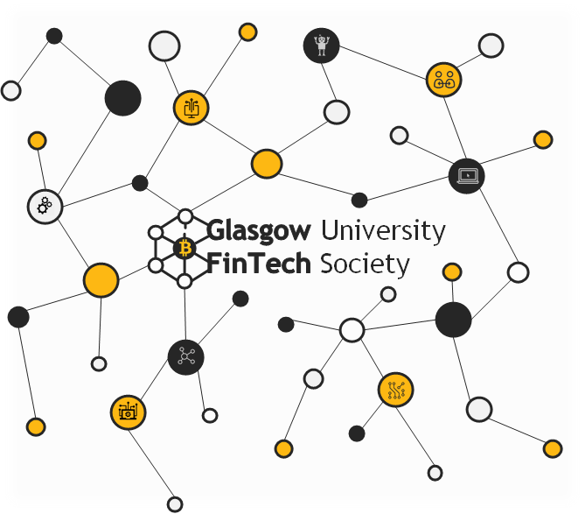

**Ethics and Regulations of Fintech**

Report

**February 2018**

**UoG Fintech Society**

[info@uogfintech.com](mailto:info@uogfintech.com)

<http://uogfintech.com>

Introduction

Welcome to another published Report of the University of Glasgow FinTech Society with title “Ethics and Regulations of Fintech”.

About the UoG FinTech society

Founded in summer 2017, we are the first student-led FinTech Society in Scotland. We bring together University of Glasgow students of any degree who are interested in technological innovations that are likely to disrupt the financial services sector. We recognise the need for developing FinTech awareness among students before their graduation as a number of surveys indicate that FinTech and FinTech technologies will play a key role in a number of industries in very near future. We also aim to give members opportunities to develop useful employability skills.

We believe we can achieve our goals by running a series of workshops throughout the academic year, which are characterised by students' cross-faculty collaboration, peer learning and engagement with industry professionals.About the “Ethics and Regulations of Fintech” report

This report and presentation slides accompanying this report were created by members of the UoG FinTech Society, namely **Elisabetta Trasatti, Heli Trivedi, Neil Kennedy and Giulia Carfora.**

This report aims to first delineate the financial regulatory approaches towards Fintech innovation and the creation of Regtech. It will then explain the ethical issues associated with the Fintech industry, especially in terms of consumer data protection, while also addressing the role of open banking in innovating the traditional financial sector. Finally, it will describe the way cryptocurrencies have been used to finance illegal activities, and the challenges in creating a regulatory framework which would prevent that illicit use.



Table of Contents

Introduction 2

About the UoG FinTech society 2

Introduction to the workshop 4

Fintech regulation approaches, challenges and the creation of Regtech 6

Approaches 6

Problems 7

Unanswered questions abound 7

RegTech 8

Customer Data Security 9

Introduction 9

How companies gather data about consumers 9

Different types of data 10

Legal and privacy issues with data collection 10

A comparison with the United States 12

Open Banking 14

Definition of Open Banking 14

What is an API? 14

A comparison between a high street bank and a challenger bank such as Monzo 15

Challenges posed by Open Banking to traditional banking 16

Use of cryptocurrencies in illegal activities 18

Anonymity factor and main crimes associated with cryptocurrencies 18

The Silk Road scandal and Bitlicense 19

New cryptocurrencies: increase in privacy and untraceability 20

Challenges for Fintech regulators: create international cooperation and regulate without stifling innovation 23

Sources 24

Introduction to the workshop

Fintech innovations over the past years have increased the speed and lowered the costs of financial services to reach a wider range of people. Their ability to offer the same banking and financial services while being less costly and less complex than well-established financial institutions has put them in the regulatory spotlight. From one perspective, if FinTech innovation could undoubtedly open a new era for the financial sector, from another, the systemic and financial risks which this innovation could unveil are not completely transparent.

Fintech has been said to challenge both the established systems of financial ethics and the regulatory frameworks that guarantee the safety and soundness of the financial system. In fact, due to Fintech innovations, financial regulatory frameworks around the world have been subject to review and modification over the past years. Governments are approaching these innovations in an active, passive or restrictive way, which means that an international regulatory framework is yet to be established. Regtech, a blend word for regulation and technology, was created to address regulatory challenges in the financial services sector through innovative technology.

Moreover, ethical issues previously not as prominent within finance, such as consumer data ethics, need to be considered and evaluated within the Fintech industry. In fact, security and privacy are top threats to the rise of Fintech, and more and more companies are being required to evaluate whether their data processing activities are legally compliant. In an effort to harmonise the rules for data protection within the EU Member States, the European Union has recently adopted the GDPR (General Data Protection Regulation), which will bring a new set of digital rights to citizens in terms of their personal data. However, it is interesting to note that while banks are being required to comply with stricter data protection laws such as GDPR, they are also increasingly shifting towards Open Banking, in which consumers authorise their banking data to be used by third parties.

Finally, another major issue concerning Fintech innovation is the use of cryptocurrencies to finance illegal activities, such as drug dealing and human trafficking. The Silk Road scandal in 2013 showed that the anonymity guaranteed by cryptocurrencies like Bitcoin can facilitate criminal activities, but it also showed the possibility of creating a “truly free market”, in which transactions happen rapidly across international borders. New cryptocurrencies, such as ZCash and Monero, have been created to ensure to users an even higher level of anonymity and untraceability than Bitcoin. This, again, poses a threat to financial regulators, who need to create an international cooperation on these issues and also a balance between protecting from risks and encouraging innovation.

Fintech regulations

The term "regulations" does not mean simply the set of rules which apply to the existing company, but it also implies the numerous rules related to the licensing of the companies and their compliance. These standards are not supposed to hold the companies' growth down, but they rather are instruments to guarantee market fairness and to prevent the risk of market failure. Moreover, appropriate regulations may be the underpinning of confidence and innovation in FinTech sector in the long run.

Approaches

The governments of various countries have adopted different approaches to regulate the FinTech industry. Regulation can determine where to locate businesses, how fast the industry grows and how start-ups can escalate in those countries. The rise in financing requires regulation and there are three routes to choose from: active, passive and restrictive approach. [1]

* **Active approach**

Regulators work closely with start-ups to understand new FinTech developments and upcoming obstacles and to help start-ups to address these challenges. This is an effective way to nurture the growth of FinTechs, although it is a focus of intensive use of resources, which always carries the risk of regulatory capture, when the regulator sets the specific interest of companies ahead of public interest. The FCA, the financial services regulator in the UK, is an example of how the regulatory body carries out an active approach. [1] The FCA allows companies affected by regulation to offer proposals at the earliest stages of drafting new regulations. Consequently, companies find it easier to comply with it because they know the requirements in advance. The FCA also provides public feedback at each stage, and explains its decisions, so it is an easy model to follow for other countries that want to build a similar model. For example, Australia has launched an Innovation Centre and works in collaboration with the FCA. A good example of an initiative of the FCA that has followed this approach is Project Innovate. [1]

* **Passive approach**

National regulators do not play an active role in trying to make FinTechs succeed, but they don’t stand in their way either. The German regulator, BaFin, has historically taken this approach, although there are signs that things are starting to change. It has recently launched an internal group whose project focuses on FinTechs, but it did so only after banks and other traditional operators had begun to partner with FinTech companies. This suggests that Germany is moving towards an active approach, although it is early to talk about an active regulatory environment as exists in the UK. [1]

* **Restrictive approach**

Governments can take this approach because they are risk averse, loaded with a lot of bureaucracy, or fear regulatory capture by the holders of the financial services industry. The United States, for example, has different regulatory bodies in each state, which means that compliance is difficult and expensive. In addition, despite the booming FinTech industry in California, and that which is emerging in New York, the commitment of regulators is still very limited. However the United States is beginning to recognize that the industry is too important and the regulations are too outdated. Recently, the OCC (Office of the Comptroller of the Currency) started an investigation into how to regulate FinTechs to foster innovation. [1]

Problems

1. FinTechs are too diverse to be included in a one-size-fits-all charter generally drafted to legitimize deposit-holding institutions. In other words, payday lenders could be lumped together with insurance tech.
2. The charter could narrow the gap between FinTechs and banks, allowing FinTechs to compete nationally instead of applying for state-by-state licenses, it could also lead to a ‘thinning of the herd’ by being too cumbersome or expensive for young companies.”
3. There’s also the possibility that FinTechs could be “written into a narrower and narrower regulatory box, increasing the chances they’re shut down for benign compliance missteps.”
4. The Office of the Comptroller of the Currency (OCC) may not protect FinTechs from other regulators who may have different sets of rules. Since we currently live in an age of de-regulation, these fears may not last much longer. [6]

Unanswered questions abound

FinTech regulation raises a host of questions. Who is the regulator in the first place? FinTech is an intersection of finance and technology and, there is lack of clarity as to the main regulator. Should FinTech be regulated as Finance or as Technology?

FinTech raises data concerns: Data is essential to the FinTech model through online storage of customer data. This in turn raises cyber security and privacy concerns. For example, where customer data is available to third-party FinTech providers for use on their apps, who is liable in cases of data breach? These issues need to be addressed to create comfort in an industry that depends on the free flow of data.

There are also consumer protection issues. FinTech is, by definition, reliant on technology and this opens it up to fraudsters seeking to extract money from consumers and FinTech companies themselves.

Intellectual property rights concerns also arise. Since FinTech thrives on innovation, how is such innovation to be afforded legal protection? Can a business method be patented, trademarked or copyrighted? If yes, where is the line to be drawn so as not to stifle innovation? Since the FinTech market is highly integrated, with so many intermediaries, how are trade secrets to be protected?

Money laundering and capital controls warrant attention too. How does FinTech fit into the current Anti-Money Laundering framework? International money transfers and foreign exchange have been greatly disrupted by FinTech companies like Money Remit. How do our regulators keep track of these transactions, conducted mostly by start-ups in different parts of the world? Our regulators, who are usually challenged capacity wise and by bureaucracy in law reform, are unlikely to keep up with the speed at which FinTech transactions evolve.

There are also competition issues. Largely, FinTech has been driven by start-ups whose technology is later adopted by the big players. How are these small players to be protected from the competition? Some large institutions have reacted to FinTech companies by gobbling them up in a spate of mergers and acquisitions and making them part of their businesses. Other FinTech companies have decided to merge with one another to stay competitive. This raises competition law issues. How are these to be addressed? What restrictions are needed? [5]

FinTech will be an integral part of the global financial sector in the near future and therefore requires a well-thought-out regulatory scheme that will cater for its idiosyncratic nature while at the same time ensuring the required control. Any realistic and effective regulatory framework should cater for the issues raised above. [5]

RegTech

A blend word of 'regulatory technology' that was created to address regulatory challenges in the financial services sector through innovative technology. RegTech consists of a group of companies that use technology to help businesses comply with regulations efficiently and inexpensively. [4]

The aftermath of the 2008 financial crisis brought about an increase in regulation in the financial sector. Concurrently, there was a rise of the disruptive use of technology within the financial sector. Technology breakthroughs led to an increase in the number of FinTech companies that create technology-driven products to enhance the customer experience and engagement with financial institutions. The reliance on consumer data to produce digital products has led to concerns among regulatory bodies calling for more laws on data privacy usage and distribution. The coupling of more regulatory measures and laws with a more technologized sector brought about the need for regulatory technology. [4]

RegTech has emerged as the technology that could address these possible regulation and compliance hurdles. Technology like AI can automate compliance awareness, monitor risk and compliance in real-time, and to automatically report to regulators. [4]

The Financial Conduct Authority, an independent U.K. financial regulatory body, has been exploring the possibility of using artificial intelligence (AI) and machine-learning tools to enforce regulatory compliance. [4]

The ethical use of personal data

Introduction

While Fintech has grown rapidly and offers several advantages such as substantial reduction in costs, improved customer retention and differentiation of financial institutions from the competition, it presents its fair share of threats and uncertainties. Security and privacy are top threats to the rise of Fintech. Indeed, the financial sector handles an enormous amount of information about individuals and enterprises (8). Nowadays, more and more data are available in digital formats and they have become such a valuable asset that they are sometimes called “the currency of the future” (9). Data is changing nearly every aspect of our lives, whether we’re aware of it or not, and this has both positive and negative consequences.

For example, data sharing forms the basis of partnerships between companies and has improved access to better products at better prices, thanks to the increase in the level of relevancy of the communications we receive, as brands now focus on the concept of “people-based marketing” and programmatic advertising.   
However, as more services go online, data security and data ubiquity are proving to be major challenges for Fintech. With the increase of online and phone banking services it’s possible to acquire a tremendous amount of information about customers, which is analysed to generate insights into buying patterns and acquisition and retention strategies. But this data, which also includes Personally Identifiable Information (PII), is also susceptible to security breaches. Protection of data, while providing them to customers and third parties in a secure manner, is therefore one of the key issues in Fintech today.

Some very interesting questions we should ask ourselves are: How do companies collect data about us? What are data used for? Who do they share our data with? Are we still in control of our personal information? It is worth remembering that data—by their very nature—can easily cross borders and play a key role in global digital economy.

How companies gather data about consumers

Most consumers ignore the fact that companies make a full-time business of gathering data about them. Forbes, a publishing company, sells data about readers who visit its site. Political campaign groups rent out their lists to firms as a way to generate cash. Credit-card companies, including Visa, MasterCard and American Express, all sell anonymised data about their cardholders to advertising companies. Bidders for advertising space can go to MasterCard to buy aggregated segments of consumers who are likely to subscribe to particular telecommunications services, for example, or stay at particular hotel chains. American Express has an edge, says someone in the data business who has worked with the company, because it actually issues the card (whereas MasterCard and Visa are in partnership with banks), enabling it to put cookies on users when they log in to check their statements and see where else they go online (11). Understandably, companies try to find out as much as they can about their consumers. Sometimes users explicitly allow services to track information about them, but often they are not asked in a very clear and explicit way, and their information can be used by third parties unknowingly.   
Some of the ways firms try to get information about their customers is tracing which devices belong to the same owner, something easier to do for companies such as Facebook and all those requiring users to log in. Some companies also try to match offline data about customers with online information.

Different types of data

Gathering information is also at the basis of the advertising industry, which mainly deals with three types of data:

* “First-party” data, which is collected directly from customers and is therefore the most relevant and accurate. Advertisers and publishers can compile them through their websites, emails and sms, mobile applications and so on. This allows companies to recognise consumers across multiple devices and to own a unique data set - unless they decide to sell it-.
* “Second-party” data, which is essentially “first-party” data obtained by another company through business partnerships. A limitation to of this type of data is that it’s quality cannot be guaranteed, as there is no control over a partner’s data assurance processes. Another issue is privacy.
* Lastly, “Third-party” data is gathered by thousands of specialist firms across the web, with no direct relationship with the subject. To identify users as they move from site to site, third parties use technologies such as cookies, web beacons, e-tags and a variety of other tools. Cookies, widely used on desktop computers, are small pieces of code that are dropped on a user’s browser. According to TRUSTe, the 100 most widely used websites are monitored by more than 1,300 firms. Some of these firms share data with other outsiders, an arrangement known as “piggybacking” (12). The problem with this kind of data is that you don’t know where it comes from and how up to date it is.

Legal and privacy issues with data collection

As data protection standards are becoming increasingly high, companies face the more and more complex task to evaluate whether their data processing activities are legally compliant, especially in an international context. The processing of personal data takes place in various spheres of economic and social activity, and the progress in information technology makes the processing and exchange of such data considerably easier. In this context, the European Union (EU) adopted the General Data Protection Regulation (GDPR) to further harmonise the rules for data protection within the EU Member States -including the UK, despite Brexit- and to raise the level of privacy for the affected individuals. The GDPR will enter into force on 25 May 2018. Due to its wide, transnational scope of application, it will also affect numerous companies located outside the EU (9). Currently, the UK relies on the Data Protection Act 1998, which was enacted following the 1995 EU Data Protection Directive, but this will be superseded by the new legislation. It introduces tougher fines for non-compliance and breaches - organizations can be fined up to 4% of annual global turnover or €20 Million, whichever is greater -, and gives people more say over what companies can do with their data.

Entities will have to make considerable efforts to get their data protection organisation into compliance with the GDPR. Different organisational requirements will have to be fulﬁlled, such as: the implementation of records of processing activities on behalf of controllers2 and processors, designation of a Data Protection Officer, a Data Protection Impact Assessment, addressing the concepts of Privacy by Design and Privacy by Default, implementation of technical measures to guarantee the safeguard of personal data. The GDPR also introduces a reporting duty of the controller towards Supervisory Authorities in case of a data breach. The notification must take place within three days and, in case of an incident with high risk for the rights of the subjects, the breach will have to be communicated to them as well. Non-EU entities that deal with EU citizens are obliged to appoint a representative located in the European Union. Lastly, self-regulations mechanisms such as Codes of Conducts, and a Data Protection Management System are highly desirable, though not mandatory (9).   
One of the biggest novelties comes with the extended jurisdiction of the of the GDPR, as it applies to all companies processing personal data of subjects residing in the Union, regardless of the company’s location (13). The regulation also expands the classic definition of personal data - such as name and identification numbers - to any online identifier, such as IP addresses and cookies, and location data. The conditions for consent to data usage have been strengthened, as its request must be given in an intelligible and easily accessible form, making it easy to withdraw consent as well (13). Among consumers’ rights there are: the right to obtain a copy of their personal data, with confirmation as to whether it is being processed and for what purpose, and the right to move their data to another company, if they wish so. The most controversial right3, however, is the “Right to be forgotten”, also known as Data Erasure, which entitles the data subject to have the controller erase his/her personal data, cease further dissemination of the data, and potentially have third parties halt processing of the data. Conditions for erasure include the data no longer being relevant to original purposes for processing, or data subjects withdrawing consent. This represents a controversial issue since subjects could decide to alter their public history in some sense, clashing with companies’ right to know who they are dealing with, as well as with freedom of press and information. Although, it should be noted that this right requires controllers to compare the subjects' rights to "the public interest in the availability of the data" when considering such requests.   
All in all, it is clear that the new regulation is particularly stressing on greater transparency and trust around data collection, privacy and sharing personal data for the individual.

A comparison with the United States

It is interesting to draw a comparison with the United States, concerning data security and privacy rights. The US doesn’t apply the same 'citizen first' approach to issues concerning data, but it is important to point out that there are two key federal laws which prevent ['unfair and deceptive practices'](https://www.federalreserve.gov/boarddocs/supmanual/cch/ftca.pdf) and make sure [children’s data](https://www.ftc.gov/enforcement/rules/rulemaking-regulatory-reform-proceedings/childrens-online-privacy-protection-rule) is protected properly. The key approaches relate mostly to [healthcare companies](http://searchhealthit.techtarget.com/definition/HIPAA) and [financial institutions](http://searchcio.techtarget.com/definition/Gramm-Leach-Bliley-Act). The state of [California](https://iapp.org/news/a/unpacking-the-california-ags-guide-on-caloppa/) has taken its own initiatives concerning privacy policies (14), for example through the enforcement of the California Online Privacy Protection Act against companies that offer mobile apps.

In the US, the First Amendment of the Constitution protects freedom of expression, including the right of an individual to speak freely. Therefore, there is [no blanket ruling](http://www.nytimes.com/2015/12/21/opinion/missteps-in-europes-online-privacy-bill.html) that allows people to delete or remove negative information about themselves online, unlike in the EU (15). In case of a breach, notification requirements vary by industry under the federal laws. For example, financial companies are required to warn customers as soon as possible if there is the risk of misuse of personal information, though companies might delay these disclosures if they could interfere with a criminal investigation (15). Lastly, there is no single federal law or standard people can rely on to obtain copies of their records. But there are industry-specific rules. Patients, for instance, may request copies of their medical records from health-care providers. Some companies, like Twitter, also allow customers to [download their own archives](https://support.twitter.com/articles/20170160) (15).

It can be said that laws in the US are wide-ranging, complex, and more general, which are not necessarily negative traits, as the EU laws are more stringent.

In conclusion, Fintech is clearly tied to the issues of privacy, data protection and security, as also shown by PwC’s Global FinTech Survey 2016, according to which 56% of the respondents identified information security and privacy as threats to the rise of Fintech. Fighting such threats requires not only the adoption of the latest technology but also a re-examination of conventional security architectures. Therefore, it is in this context that the upcoming regulations are to be seen in a positive light, as they will provide firms with vital guidance.

Notes:

1 Where ‘processing’ means any operation or set of operations that is performed on personal data or on sets of personal data, whether or not by automated means, Art. 4 No. 2 GDPR.

2 A ‘controller’ is a natural or legal person, public authority, agency or other body that, alone or jointly with others, determines the purposes and means of the processing of personal data, Art. 4 No. 7 GDPR.

3 A famous case is that of Mario Costeja González: https://en.wikipedia.org/wiki/Google_Spain_v_AEPD_and_Mario_Costeja_González

Open Banking

The personal banking sector in the UK is a heavily consolidated market dominated by large, established players. Around 80% of people in the UK bank with 5 major banks (RBS, HSBC, Santander, Barclays, Lloyds).

In 2016, the CMA introduced plans to adopt Open Banking which requires the UK’s 9 biggest banks to allow authorised 3rd party services to be built on top of their data. It is hoped that this will promote innovation in the banking sector and stimulate competition.

Definition of Open Banking

Open Banking means that consumers can authorise their banking data to be used by a 3rd party service. Services such as Yolt; an account aggregator where users can integrate multiple bank accounts and view personalised financial insights, can be further integrated with our banking data (with our permission). The list of possible services which can be built and improved because of Open Banking is endless. It allows small startups to experiment with new technologies that larger banks are much slower to adopt; providing a benefit to the consumer. Personalised financial insights and planning using machine learning and AI, faster and more convenient payment methods and multi-currency integration are a few examples of areas in which Open Banking can facilitate innovation.

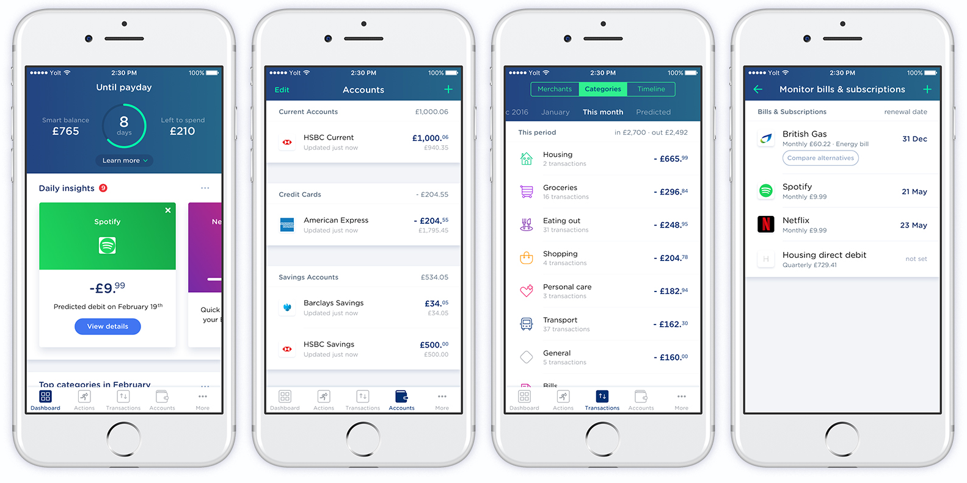

Examples of Yolt’s features

What is an API?

The engine powering Open Banking is APIs. An API (Application Programming Interface) is a set of functions which allows one piece of software to access the data or functionality of another piece of software. They essentially allow a flow of data between pieces of software. APIs are the backbone of many internet features we take for granted. Websites and apps make extensive use of APIs to get data from other places (e.g. financial or weather data). Many internet users come face to face with APIs every day through common features such as logging in or registering to a service with a Facebook/Google/Twitter account. In this instance, the service that a user is signing up for is authorised to communicate with Facebook etc to get a user’s key data to make an account. This provides a fast, reliable and user friendly way to register for a new service.

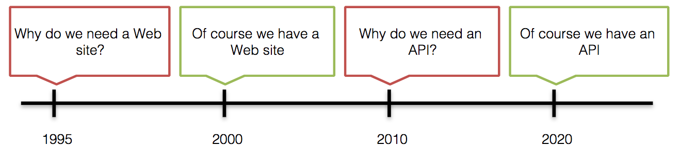

In order banks to allow 3rd party services to use and build services from their data, the banks have to provide an API. This presents a unique architectural challenge for banks, particularly the larger banks with more dated and fragmented data architectures. Many core banking data architectures of the UK’s largest banks were designed in the 1970s - 1980s and have not been seriously upgraded in recent times. Since Open Banking APIs rely on approved copies of master data sources, it is important for banks to transition to a more reliable data architecture. Current data architectures are often very fragmented; with duplicate data, multiple data stores and point-to point interfacing. To ensure reliable data can be accessed, banks are moving to a more streamlined architecture with a centralised gateway for accessing data.

Open Banking is seen as a major annoyance by some in the banking industry. It forces large, legacy banks to undertake a programme of overhauling the IT architecture which is expensive and time consuming. The counter argument is that this forced overhaul is a much needed modernisation which will allow these banks to remain competitive, create partnerships between banks and FinTechs, and stimulate innovation. It is important to realise just how old many large banks’ technology infrastructure is.

A comparison between a high street bank and a challenger bank such as Monzo

When making a contactless purchase with a high street bank card, it will take at least a few days, sometimes up to a week for this purchase to be shown in a banking app. There will also be very little data other than the name of retailer and amount paid.

Contrast this with a contactless payment using a Monzo card. Within a few seconds, the user will receive a notification on the app showing amount, merchant & location of purchase.

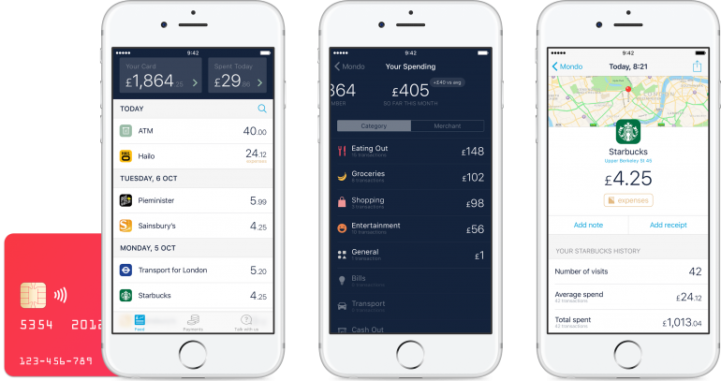

The technology infrastructure of high street banks cannot handle the speed or amount of data that challenger banks such as Monzo can. Moreover, this isn’t just because Monzo has fewer customers (they have around 360,000 current account holders as of February 2018); Monzo have built a highly scalable distributed architecture. They have achieved this by making extensive use of microservices (essentially a modular architecture), including building an open source wrapper around the programming language Go’s protocols.

Challenges posed by Open Banking to traditional banking

The way we bank is changing. Challenger banks such as Monzo, Revolut and Starling have mobile-first, technologically superior services compared to the high street incumbents. Open Banking may be seen as an annoyance, but it may actually be the best thing to happen to large banks. It forces banks to modernise their infrastructure and forge partnerships with FinTechs. This fosters an environment of innovation, not just in the banking sector as a whole; but within banks themselves. This will encourage banks and financial institutions to innovate, and put the customer first.

Another law, GDPR, is also forcing banks (and all companies) to change the way they deal with customer data. GDPR (the General Data Protection Regulation) is an EU-wide law (likely to be adopted in the UK post-Brexit) which deals with consumer data security. The law provides consumers with more control over how their data is managed (e.g. right to be forgotten), and also imposes principles on how companies store data (e.g. pseudonymisation, encryption). GDPR is difficult for companies to implement; in many cases, it lays out principles of data protection rather than specific procedures to be followed. This places a large burden on companies to figure out the proper way to comply. The penalties for breaching GDPR are heavy - for the most serious breaches, a company can be fined €20 million or up to 4% of annual global turnover.

GDPR and Open Banking impose a similar need to overhaul the data architecture for banks. Duplicate and fragmented data stores can result in breach of GDPR. In some cases, the data architecture is so fragmented that it can be difficult for the bank to keep track of what data is stored where. A unified data architecture is required.

It is an interesting side note that at the same time, banks need to open up their data for use by 3rd parties (Open Banking), while being forced to comply with ever stricter data protection laws (GDPR). This combination has presented an urgent need for banks to overhaul their underlying technology.

Use of cryptocurrencies in illegal activities

As innovation in Fintech is advancing at a very rapid pace, there is a need for regulators to elaborate a legal framework in which the industry can operate. In fact, while innovation can lead to positive outcomes in the financial sector such as the reduction of transaction costs and the improvement of efficiency, it can also facilitate illegal activities such as money laundering, terrorism financing and illegal trade. Regulators need to recognise the Fintech innovation as a two-faced phenomenon in order to protect their countries from the risks of illegal activities without stifling innovation and imposing overregulation over the industry.

Anonymity factor and main crimes associated with cryptocurrencies

The main factor that makes cryptocurrencies a potential facilitator of illegal activities is the fact that they guarantee a high degree of anonymity (21). Although each transaction is recorded in the blockchain – which, taking Bitcoin as an example, prevents the same bitcoin to be spent a second time after it has already been transferred – neither the sender nor the recipient of the transaction can be connected to a specific identity (21). This means that cross-border payments made via cryptocurrencies not only require less time to be transferred, but they are also difficult to trace. The anonymity factor of cryptocurrencies has been said to shift the balance of power in the financial sector more towards the individual and further from the state (19). In fact, it has morally controversial implications in terms of the freedom of the individual to trade and to accumulate and move financial capital. As the CEO of JPMorgan Chase bank, Jamie Dimon, stated in a recent interview, “Nations make currencies, but they like to have central banks controlling them. They like to know who has it, where it is going and why is it going there” (27).

For example, drug and human traffickers are often willing to accept the high volatility of cryptocurrencies because of the degree of concealment it guarantees to their transactions. Although the first illegal activities which exploited the use of cryptocurrencies were money laundering, drug trafficking and online gambling, it has now also started to be used in the illicit economy of prostitution. The US Department of Justice “Virtual Currency Emerging Threats Working Group”, created by the FBI in 2013, declared in an official document that “early users of virtual currency included criminals involved in the trafficking of child pornography, credit card fraud, identity theft, and high-yield investment schemes. As virtual currency became more widespread and criminals became increasingly computer savvy, other criminal groups moved to capitalize on virtual currency, as well. There are now public examples of virtual currency being used by nearly every type of criminal imaginable” (26).

The Silk Road scandal and Bitlicense

Silk Road, an anonymous online exchange platform launched in 2011 where drug dealers and buyers were connected in an “incredibly smooth and simple way” (19, p. 64), exploited that freedom to trade guaranteed by cryptocurrencies to the most extreme extent. The website, in which anonymous web browsing was ensured by the use of Tor (The Onion Router. Which anonymises the IP address of the user), was described by its supporters not only as a way to defy government, but also as a “truly free market”.

There is no doubt that Silk Road was a facilitator of an illegal kind of trade, but the platform also showed the possibility of creating a system in which transactions can happen rapidly across international borders and among anyone who has access to the Internet.

One of the most important ways in which Fintech can innovate the financial sector is, in fact, by making cross-borders transactions more efficient. This is because cryptocurrency transactions do not have go through numerous intermediary banks and jurisdictions before reaching the destination.

Moreover, the case of Silk Road offers a starting point of discussion on how governments should deal with such financial crimes which are facilitated by technological innovation. Within days of the arrest of Ross Ulbricht, the creator of the website, on 3rd October 2013 (32), there were already a number of projects for the creation of a “Silk Road 2.0”. As it has been argued by Dowd, “The combination of anonymity and independence means that governments cannot bring down Bitcoin by conventional methods, although they may occasionally catch individuals and organisations that are careless. They cannot bring Bitcoin down by taking down particular individuals or organisations because the system is not dependent on any individual or organisation: there is no single point of failure.” (19, p. 79).

In other words, it is the decentralised nature of cryptocurrencies that cannot fit with the traditional regulatory models (22).



It is also noteworthy that the Silk Road scandal pushed the New York State Department of Financial Services (NYDFS) to create a new regulatory framework for virtual currencies called BItlicense. One of the main actors in the construction of this document was Benjamin Lawsky, at the time Superintendent of Financial Services, who was “essentially given the opportunity to write the rules for this whole new industry from scratch” (23). One of the primary goals of Bitlicense was to significantly decrease the strength of the link between Bitcoin and the dark web, by requiring companies to record more information about date and time, amount, account numbers, physical addresses, names involved in the transaction, for each of the transactions they executed. As the United States Department of Justice stated in a 2013 document published online, “as members of the U.S. financial community, virtual currency services can and must safeguard themselves from exploitation by criminals and terrorists by implementing legally required anti-money laundering and know-your-customer controls” (26).

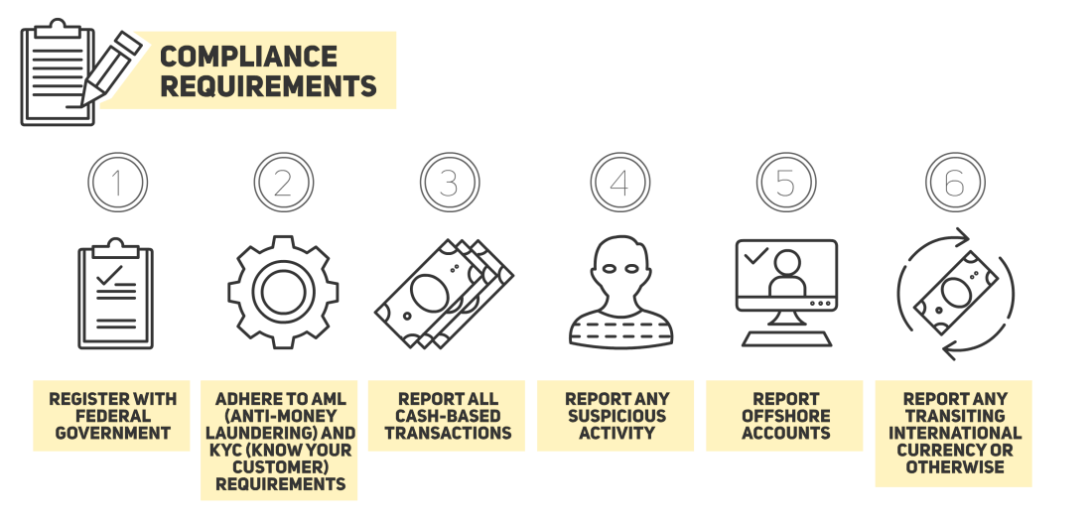

<https://cointelegraph.com/news/cryptocurrency-regulation-in-the-international-community-2015-part-2>

New cryptocurrencies: increase in privacy and untraceability

A recent study, conducted in January 2018 by the three Business Schools of the University of Sydney, University of Technology Sydney and Stockholm School of Economics in Riga, found that about one half of all bitcoin transactions are currently associated with illegal activity (25). The authors defined bitcoin as the correspondent for the darknet marketplace of Paypal for Ebay, as both payment mechanisms are used primarily for their reliability, scalability and convenience.

However, cryptocurrency could also be used by law enforcement agencies to detect illegal activity. In fact, a study conducted in the United States in 2014 showed that it is possible to link Bitcoin addresses with IP addresses. As UCL professor in cryptography Sarah Meiklejohn said: “The beauty of Bitcoin, from a detective’s point of view, is that the blockchain records all. If you catch a dealer with drugs and cash on the street, you’ve caught them committing one crime. But if you catch people using something like Silk Road, you’ve uncovered their whole criminal history It’s like discovering their books”.

https://cointelegraph.com/news/just-how-anonymous-are-bitcoin-transactions

This finding about the potential traceability of Bitcoin has already led to the creation of new cryptocurrencies to provide users with greater privacy. Some examples are Monero and ZCash, which was launched in 2016 and in which sender, recipient and transaction amounts are hidden: the only information available on the ZCash blockchain is the time at which the transactions occurred (24).

Monero uses ring signatures to ensure transactions’ privacy: “Monero provides all the benefits of a decentralised cryptocurrency, without any of the typical privacy concessions” (27). Ring signatures are a type of digital signature in which a group of possible signers are fused together to produce a distinctive signature that authorizes a transaction. This means that the actual signer is combined with non-signers to form a ring: all ring members are plausibly the actual signer of the transaction, so its origin remains untraceable. Compared to ZCash, where users enable their own privacy features, Monero is confidential by default (28).



<https://cypherowl.com/why-monero-privacy-focused-cryptocurrency/>

For these reasons, Monero’s popularity is rising in the Dark Web world. The results of a recent poll on one of the most popular Dark Web criminal forums showed that the users of the website want it to support the use of Monero over Bitcoin and other cryptocurrencies in the future (29).

 https://www.bleepingcomputer.com/news/cryptocurrency/litecoin-not-monero-is-the-second-most-dominant-dark-web-currency/

Challenges for Fintech regulators: create international cooperation and regulate without stifling innovation

It is evident that governments across the world are now faced with the challenge of creating new regulatory frameworks to prevent illegal activities in the Fintech industry. In doing so, they need to pose particular attention on the issue of international collaboration. In fact, there is a need to create a global agreement on the regulation instead of a number of national regulations. Traditional AML (Anti-Money Laundering) and CTF (Counter-Terrorist Financing) regulations often differ from country to country (20). Instead, effective regulations for Fintech activities can only be effective if they are the result of an international cooperation on cybersecurity issues, since cryptocurrency transactions are by nature borderless (21). This is fundamental to avoid the so-called regulations’ “extraterritorial effects”, which, for example, obligate a Canadian firm operating in Singapore to comply with both the countries’ regulations (21). To address such problems posed by the fragmentation of regulatory frameworks, international bodies like the FATF (Financial Action Task Force) and the UNODC (United Nations Office on Drugs and Crime) are being used as a forum for the discussion of the issues posed by cryptocurrencies (22).

Sources

1. Types of FinTech regulation: active, passive and restrictive <https://www.bbva.com/en/types-fintech-regulation-active-passive-restrictive/>
2. Regulating FinTech: getting the response right <https://www.endofbanking.org/regulating-fintech-getting-the-response-right-150714123/>
3. How the FinTech revolution is changing the regulatory approach: <https://www.fintastico.com/blog/how-fintech-revolution-changing-regulatory-approach/>
4. Regtech: <https://www.investopedia.com/terms/r/regtech.asp>
5. FinTech is the new normal but brings with it regulatory headaches: <https://www.bowmanslaw.com/insights/fintech/fintech-new-normal-brings-regulatory-headaches/>
6. An obscure regulatory debate has put the entire U.S. Fintech community on edge: <https://techcrunch.com/2017/04/24/an-obscure-regulatory-debate-has-put-the-entire-u-s-fintech-community-on-edge/>
7. The Economy Needs Fewer, Better Fintech Regulations: <http://observer.com/2017/06/economy-needs-fewer-better-fintech-regulations-business-finance-markets-recession-financial-products/>
8. https://www.pwc.in/assets/pdfs/consulting/cyber-security/banking/security-challenges-in-the-evolving-fintech-landscape.pdf
9. The EU General Data Protection Regulation (GDPR) – A practical guide by Paul Voigt, Axel von dem Bussche
10. Experian #7for17 paper available at: <file:///C:/Users/giuli/Desktop/Fintech/Experian%207for17.pdf>
11. Getting to know you – The Economist
12. Private data, public rules – The Economist
13. <https://www.eugdpr.org/the-regulation.html>
14. <https://www.pensar.co.uk/blog/data-protection-in-the-us-vs-europe>
15. <https://www.nytimes.com/interactive/2016/01/29/technology/data-privacy-policy-us-europe.html>
16. What is Open Banking and PSD2? WIRED explains - <http://www.wired.co.uk/article/open-banking-cma-psd2-explained>
17. Open Banking Project - Reference Architecture <https://github.com/OpenBankProject/OBP-API/wiki/Open-Bank-Project-Architecture>
18. OBP at the Heart of your PSD2 Strategy - Open Banking Project <https://openbankproject.com/media/filer_public/b3/af/b3afd563-3782-4966-8fca-0139613306f4/simon_redfern_-_obp_at_the_heart_of_your_psd2_strategy.pdf>
19. Dowd, K. (2014) New private monies. London: The Institute of Economic Affairs.
20. McQuinn, A., Guo, W. and Castro, D. (2016) Policy Principles for Fintech, Information Technology and Information Foundation, October 2016.
21. Lim, J. (2015) A Facilitative Model for Cryptocurrency Regulation in Singapore, Handbook of Digital Currency.
22. International Monetary Fund Staff Team (2016) Virtual Currencies and Beyond: Initial Considerations, IMF Staff Discussion Note.
23. Banking on Bitcoin. (2016) [video]. USA: Christopher Cannucciari
24. Steemit.com (2016) A Lesson in anonymity: Bitcoin, Dash, Monero and Zcash. [online] Available at: https://steemit.com/money/@thecryptodrive/a-lesson-in-anonymity-bitcoin-dash-monero-and-zcash [Accessed 10 Feb. 2018].
25. Foley et al. (2018) Sex, drugs, and bitcoin: How much illegal activity is financed through cryptocurrencies?.
26. Justice.gov. (2013). Acting Assistant Attorney General Mythili Raman Testifies Before the Senate Committee on Homeland Security and Governmental Affairs. [online] Available at: https://www.justice.gov/opa/speech/acting-assistant-attorney-general-mythili-raman-testifies-senate-committee-homeland [Accessed 11 Feb. 2018].
27. Peterdegedo.com. (2017). 25.09.17 Dark Web and Cybercrime Roundup – Deep Dot Web – Peter Degedo. [online] Available at: https://www.peterdegedo.com/2017/09/26/25-09-17-dark-web-and-cybercrime-roundup-deep-dot-web/ [Accessed 23 Feb. 2018].
28. CypherOwl. (2018). Why Monero? - Privacy Focused Cryptocurrency. [online] Available at: https://cypherowl.com/why-monero-privacy-focused-cryptocurrency/ [Accessed 23 Feb. 2018].
29. Cimpanu, C. (2018). Litecoin, Not Monero, Is the Second Most Dominant Dark Web Currency. [online] BleepingComputer. Available at: https://www.bleepingcomputer.com/news/cryptocurrency/litecoin-not-monero-is-the-second-most-dominant-dark-web-currency/ [Accessed 23 Feb. 2018].
30. Cointelegraph.com. (2017). Just How Anonymous are Bitcoin Transactions?. [online] Available at: https://cointelegraph.com/news/just-how-anonymous-are-bitcoin-transactions [Accessed 23 Feb. 2018].
31. Cointelegraph.com. (2015). Cryptocurrency Regulation in the International Community 2015: Part 2. [online] Available at: https://cointelegraph.com/news/cryptocurrency-regulation-in-the-international-community-2015-part-2 [Accessed 23 Feb. 2018].
32. Repubblica.it. (2014). L'Fbi arresta a San Francisco il fondatore di Silk Road 2.0. [online] Available at: http://www.repubblica.it/tecnologia/2014/11/06/news/arrestato_capo_di_silk_road_2-99933316/ [Accessed 23 Feb. 2018].